Environmental Setup

To develop a web application using HTML, you can use simple editors such as Notepad or go for IDEs like Visual Studio Code(recommended), Eclipse etc. which makes coding easier.
And, to execute application, you can use any commonly used browser such as Google Chrome(recommended), Mozilla Firefox etc.
Let us understand how to set up the environment to develop a web application using Visual Studio Code.
Create the below-mentioned HTML page in Visual Studio Code by the following steps:
- Open Visual Studio Code from the Start menu.
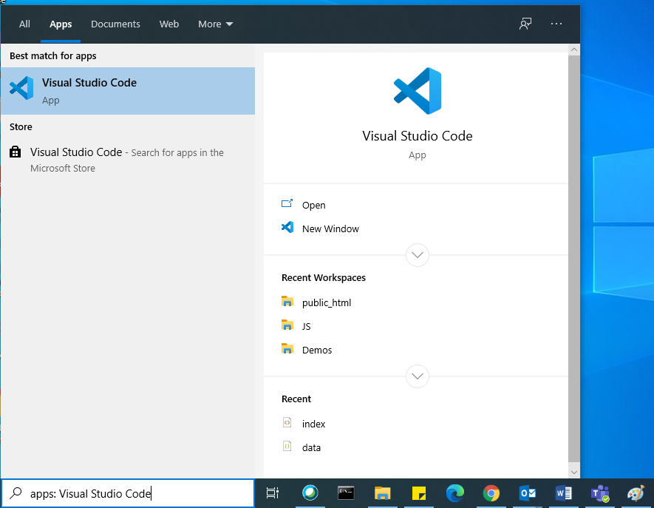
- Once Visual Studio Code is launched, Open your local workspace by clicking the File menu and selecting the 'Open Folder' option.
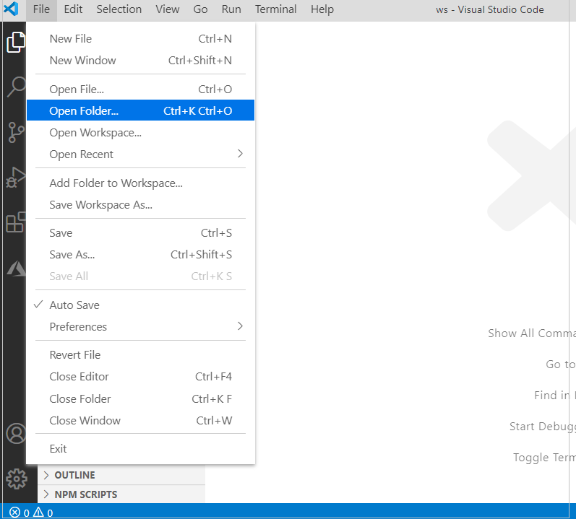

- Create a new file by clicking the new file icon as shown below.
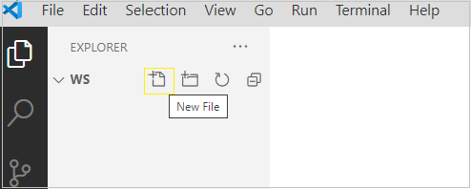
- Name the new file as index.html, and type the below-mentioned code in it.
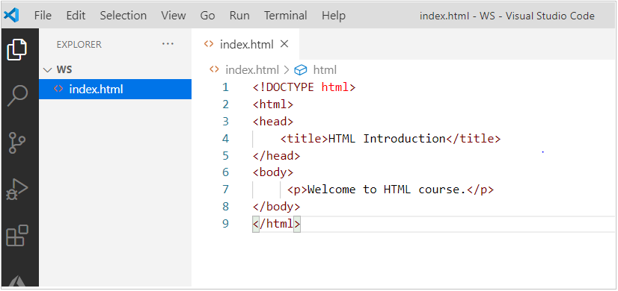
index.html
- <!DOCTYPE html>
- <html>
- <head>
- <title>HTML Introduction</title>
- </head>
- <body>
- <p>Welcome to HTML course.</p>
- </body>
- </html>

To render this HTML file, right-click on index.html as shown below and copy the path of index.html into the browser
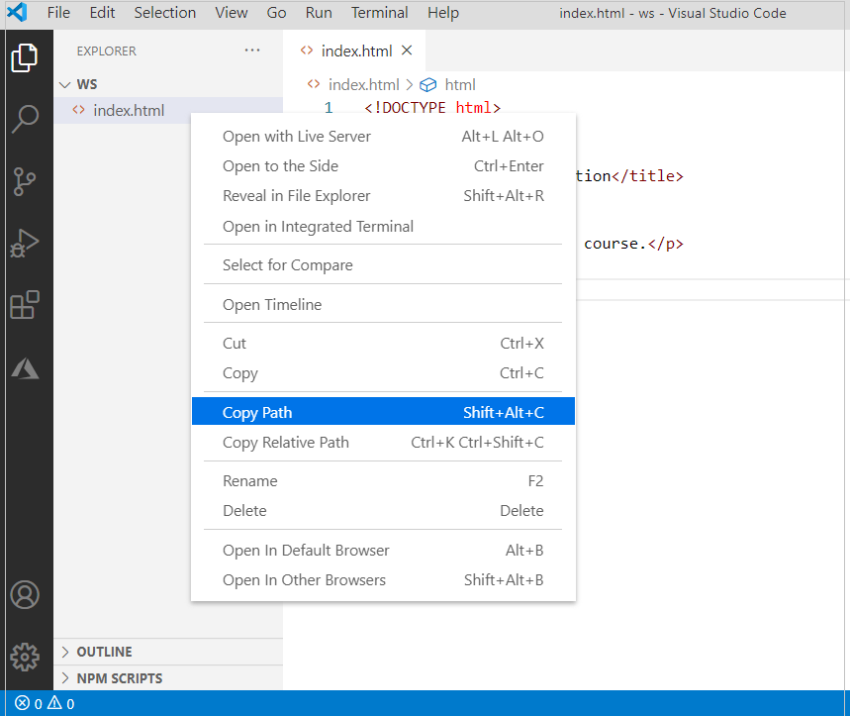

And the output will be displayed as below:
Output:
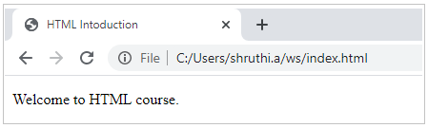
Adding Live Server

In the previous example, each time whenever we make subtle changes in the code we will be forced to refresh the page for the changes to reflect.
There is a solution to this in the Visual Studio Code.
Visual Studio Code IDE provides an extension called Live Server using which HTML page can be rendered and any changes that developers make further will be automatically detected and rendered appropriately.
Follow the below steps to add Live Server:
1. Go to the extension tab in Visual Studio Code and search for Live Server and Click on the Install button.
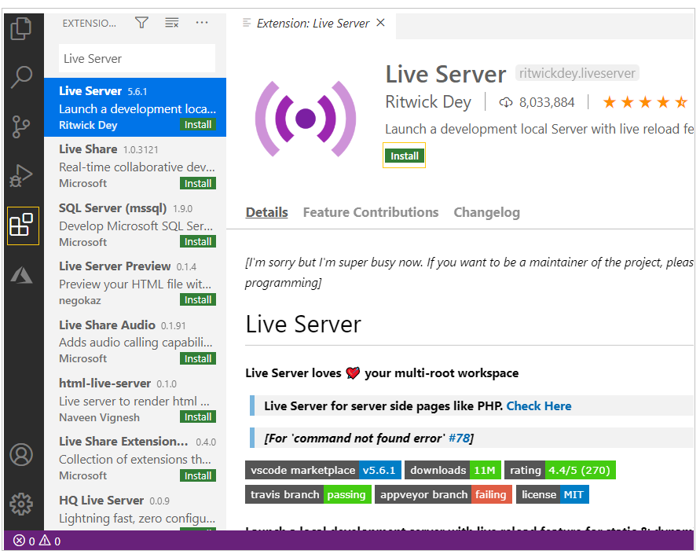

2. Once the Live Server extension is successfully installed, an HTML page can be rendered by right-clicking on the intended HTML page in the Explore tab and select the ‘Open with Live Server’ option as shown below:

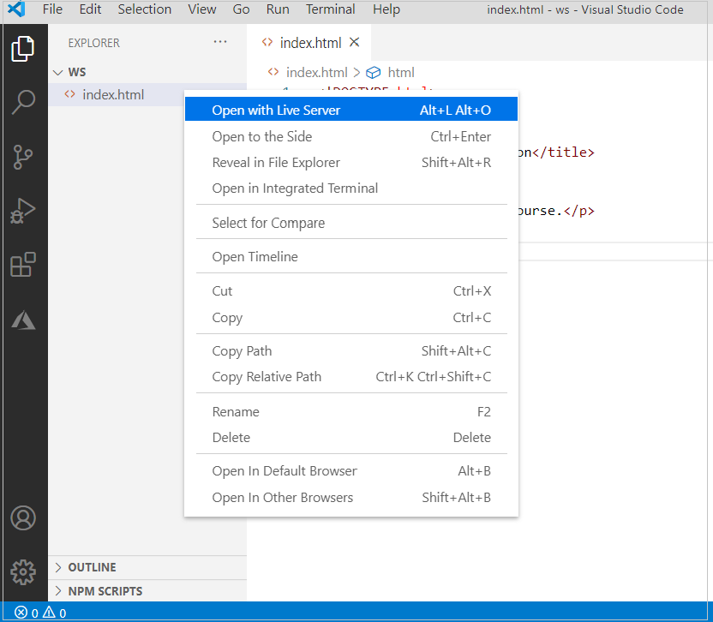
And, you can observe the output as below:
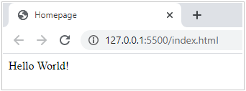

Need of HTML

HTML is needed to fill online forms in web applications as below:
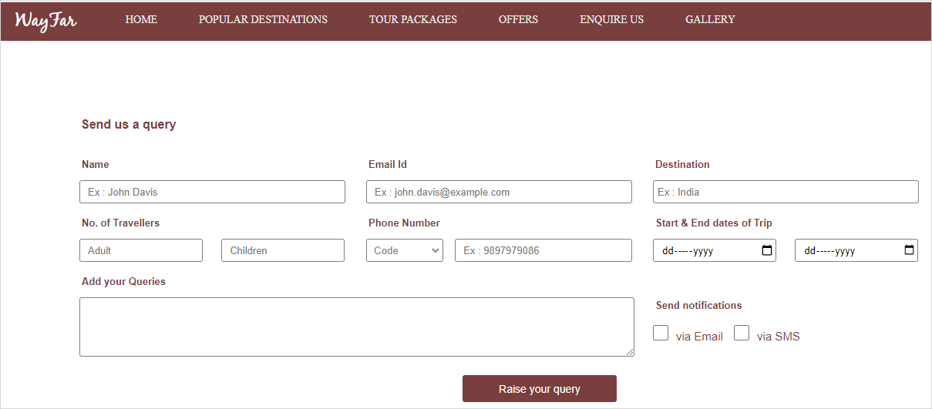
Also, with the help of HTML, we can watch online videos on Youtube.
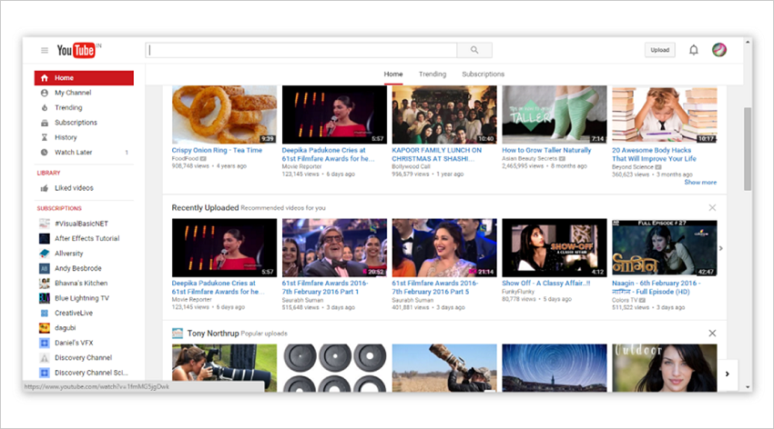

While browsing the Web, when you click on a hyperlink, you navigate to another web page. This is possible with the help of HTML.

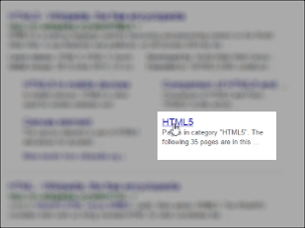
Do you know, how these web pages with different content types such as text, hyperlinks, forms, images, and videos are created in web applications?
You can achieve all these requirements using HTML.
Machine Readability

As web pages are read by computer programs like search engines and assistive tools, a web developer needs to ensure machine readability.
HTML allows us to provide correct semantics (meaning) to web page content which in-turn enhances machine readability of web pages.
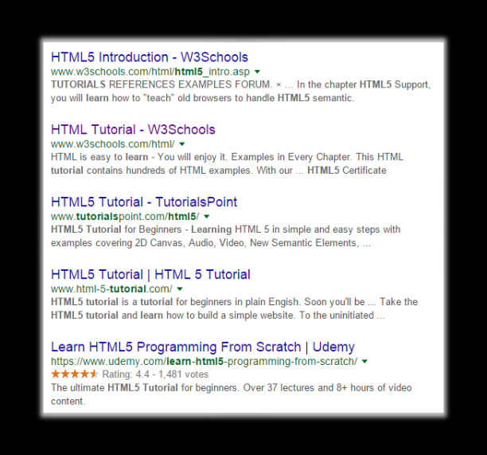

HyperText Markup Language (HTML)

Hyper Text Markup Language (HTML) is a standard markup language to create the structure of a web page. It annotates the content on a web page using HTML elements.
In a web page, all instructions to the browser are given in the form of HTML tags, also known as HTML elements.
The content of the web page will be rendered as per the HTML tags in which they are enclosed.
Observe the below picture.
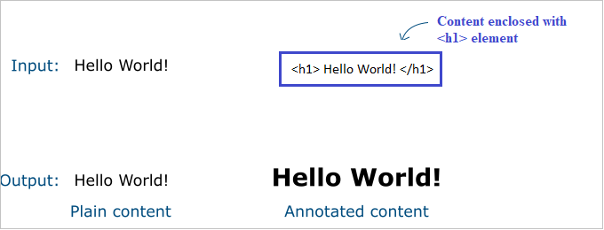
The text content "Hello World!" is annotated to the heading, increasing the font-weight when it is enclosed in the HTML tag <h1>.
Likewise, the look and feel of the web page can be defined and the content can be organized on the web page with the help of various HTML elements.
Now, let us see the document structure of HTML.
Basic Document Structure

HTML document structure tells the browser how to render the text written in each of the HTML elements of the web page.
Consider that we need to create a web page, the basic HTML document structure will be as below:
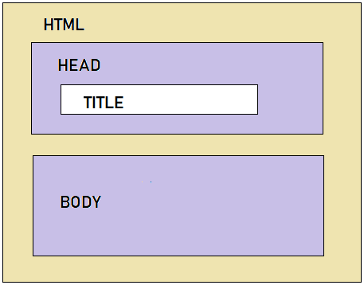
The structure of an HTML document is defined using HTML tags.
Below is the basic structure of a simple HTML document or web page:
- <!DOCTYPE html>
- <html>
- <head>
- <title></title>
- </head>
- <body>
- </body>
- </html>
Now, let us understand these basic HTML tags in detail.
Basic Document Structure - Elements

The following are some key elements in HTML that form the basic structure of a web page.
- <!DOCTYPE html> declaration update the browser about the version of HTML being used. By default, it points to HTML5, the latest version.
- The <html> tag encapsulates the complete web page content. All other tags are 'nested' within the <HTML> tag.
- Any HTML document or web page consists of two main sections the 'head' and the 'body'.
  - The head section starts with the start tag <head> and ends with the end tag </head>.
The following elements can be provided within the head tag.
Tags | Description
<title> | Defines the title that should be displayed on the browser tab
<meta> | Metadata is in-general, data about data.  Provides metadata about the HTML document.  Metadata will not be displayed on the page but will be machine-readable.  Used to specify page description, author of the document, last modified, etc.  Used by browsers (control how to display content or reload the page), search engines (keywords), or other web services.  Post HTML5, meta tag also allows web designers to take control over the viewport by setting the meta viewport tag.
<style> | Defines style information for the web page
<link> | Defines a link to other documents like CSS
<script> | Defines script like JavaScript
- The body section is denoted within the start tag <body> and ends with the end tag </body>. This section contains actual web page content like text, images, etc.

Every HTML document/web page will have only one set of
- <html>...</html> tag
- <head>...</head> tag
- <body>...</body> tag
HTML document/web page is saved with .htm or .html extension.

Case-insensitivity

HTML elements are case-insensitive. The browser understands the HTML tags irrespective of their cases.
Consider the code snippets below, copy the snippets to your workspace and observe the output
Code 1:
- <!DOCTYPE html>
- <html>
- <head>
- <title>Homepage </title>
- </head>
- <body>
- Hello World!
- </body>
- </html>

Code 2:
- <!DOCTYPE html>
- <html>
- <head>
- <title>Homepage </title>
- </head>
- <body>
- Hello World!
- </boDy>
- </html>

You can observe that both codes generate the same output as below:
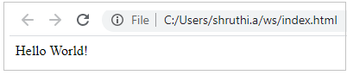

Platform-independency

HTML Language is platform-independent. That means the same HTML code can run on different operating systems as shown below.
Sample.html
- <!DOCTYPE html>
- <html>
- <head>
- <title>sample page</title>
- </head>
- <body>
- <p>Hello World!</p>
- </body>
- </html>

Output:
On executing the above-mentioned code we can observe the same output in different platforms as shown below:
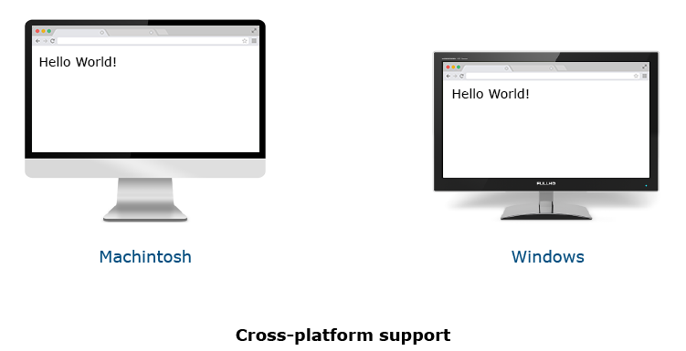

DOCTYPE Declaration

There are many versions of HTML out there such as - HTML 2.0, HTML 3.0, HTML 3.2, HTML4.0, HTML 4.01 and latest is HTML5.0. In each version, some elements and attributes are either added or depreciated. The appearance of your .html page depends on how the browser renders HTML elements. And how the browser renders HTML elements depends on how the browser understands them.
Thus, to ensure that the browser understands all HTML elements specific to a particular version, as a developer you need to tell the browser what version of HTML you have followed while developing your web page.
This is done by using <!DOCTYPE> declaration which stands for Document Type. It tells the browser what version of HTML it should follow for rendering the web page.
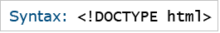
HTML file begins with <!DOCTYPE> declaration as below:
Sample.html:
- <!DOCTYPE html>
- <html>
- <head>
- <title> Sample page </title>
- </head>
- <body>
- Hello world!
- </body>
- </html>
In the above code, <!DOCTYPE html> signifies that, the code is written in HTML5.

Best Practice:
Provide a proper DOCTYPE declaration while designing an HTML web page, so that browser can understand the version and interpret elements of the web page appropriately.

Types of Elements - Container/Empty Elements

HTML elements can be broadly categorized into two as below:
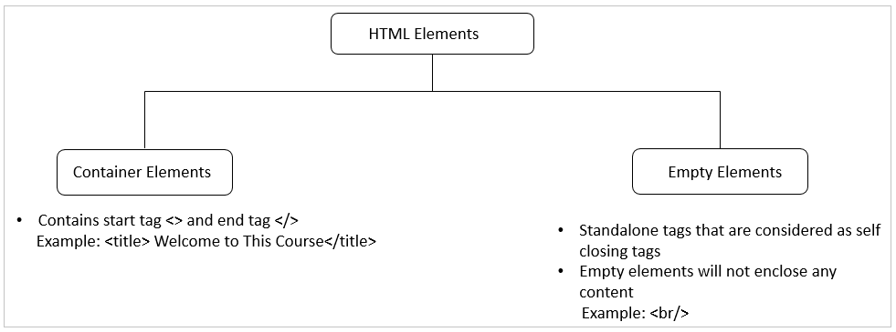

Types of Elements - Block/Inline Elements

HTML elements can be further categorized into two as below:
Block Element:
A block element begins on a new line occupying the entire width of the parent tag.
Inline Element:
An inline element occupies the necessary space to accommodate the content in the element. Inline elements can be nested within other inline elements, whereas, block elements cannot be nested within inline elements.
Some of the examples are illustrated below:
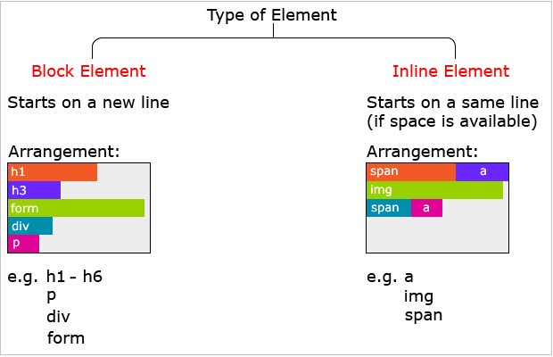

HTML Elements - Attributes

HTML elements can contain attributes that can be considered as an additional feature to set various properties and they are optional.
Some of the attributes can be used with any of the HTML elements and there can be referred to as ‘global attributes’. Also, some attributes can be used only with particular elements. Following are some features of attributes:
- All the attributes can contain properties like name and value which can be used by a developer to assign respective details for that HTML elements.
- Attributes are to be set only in the start tag of a container HTML element.
- Attributes are case-insensitive, but it is recommended to use lowercase as a best practice.
- The best practice is always to quote attribute value even though we will not get any execution errors if they are not provided in quotes.
Example:
The lang attribute specifies the language of the content of the HTML page.
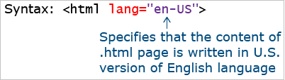
Comment
As a developer, you may want to document your code, so that you can easily refer to it in the future.
For this, comments are used.
Comments are ignored by the browser.

Grouping Elements - Need
While developing any web page there may be needed for us to develop some pages like About Us, Terms and Conditions, News report, etc. which would contain a lot of textual information, in that situation we might commonly come across the below-mentioned scenarios:
1. The need to associate mandatory visual spacing between logical portions of the textual description so as to improve text readability. Have a look at the below About Us page, for example.

The page provides a basic description of what the website essentially does and also details what it especially offers to its members. Logically, these two descriptions are separate and the same need to be conveyed visually to the user as well so that the readability of webpage content is achieved.
2. The need to highlight the topic headings. For example: In the below Terms and Conditions page,
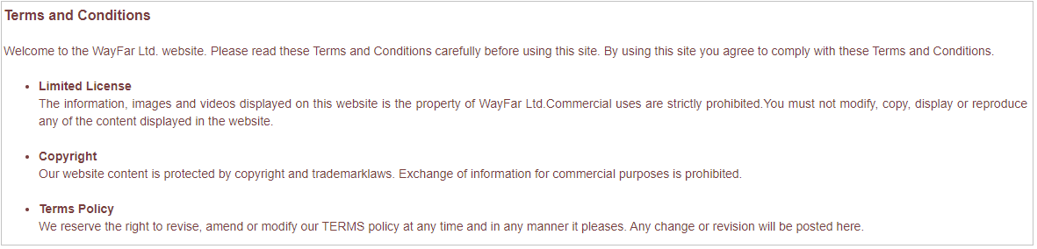
The topic headers like “Limited License”, “Terms Policy”, etc are highlighted so that the user can quickly differentiate the respective topic description on the webpage.
3. The need to group various portions of a web page for various reasons like applying some common styling. For example, in the below screen, descriptions related to Limited License, Copyright, Terms Policy needs to be grouped for applying a common style of black color text
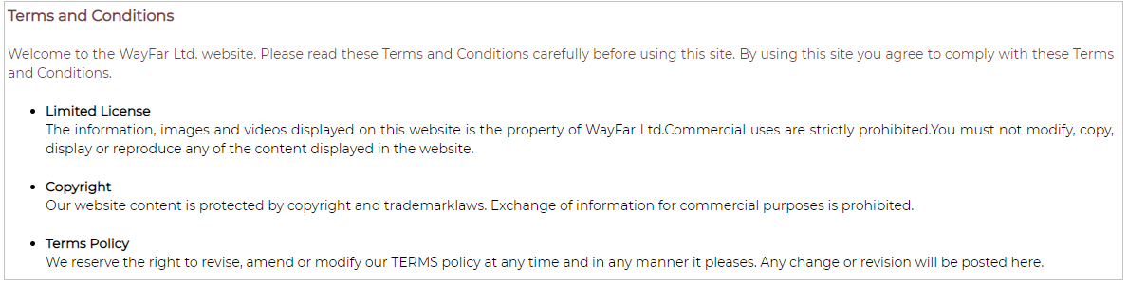

Grouping Elements in HTML
Grouping elements in HTML5 can be categorized majorly as below:
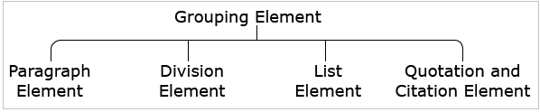
Paragraph Element
The paragraph element is generally used for denoting a paragraph. Any textual content can be mentioned inside this element.
It is defined using <p>…</p> tag.
Let us understand this with an example.
Copy the below code into your Visual Studio Code workspace.
demo.html
- ​<!DOCTYPE html>
- <html>
- <body>
- <p>This is a Paragraph</p>
- </body>
- </html>
To execute this code:
- Right-click on the file demo.html
- Select the option "Open with Live Server"
- Right-click on the browser, and select the inspect option.
In the pop-up window, observe the 'Elements' tab as below:
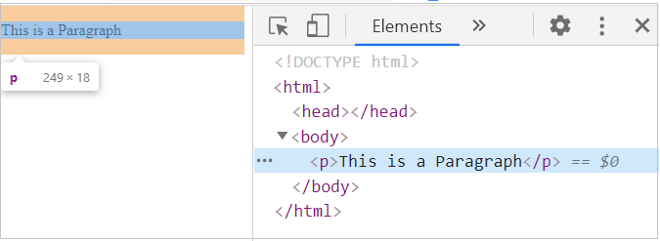
We can observe that the paragraph element is a block-level element and hence adds a new line automatically when a paragraph ends. This ensures visual spacing between consecutive paragraphs of text.
Division Element
The division element is used to group various other HTML tags. This element helps us in organizing the web page into different sections.
If any common rule or style needs to be added to a particular section, the same can be applied to the corresponding division. The rule or style gets applied to all the contents of the division thereby.
It is defined using <div>…</div> tag.
Let us understand this with an example
Copy the below code into your Visual Studio Code workspace.
demo.html
- <!DOCTYPE html>
- <html>
- <body>
- <div>
- <p> This is first paragraph </p>
- <p> This is second paragraph </p>
- <p> This is third paragraph </p>
- </div>
- </body>
- </html>
To execute this code:
- Right-click on the file demo.html
- Select the option "Open with Live Server"
- Right-click on the browser, and select the inspect option.
The division element is used to group various other HTML tags. This element helps us in organizing the web page into different sections.
If any common rule or style needs to be added to a particular section, the same can be applied to the corresponding division. The rule or style gets applied to all the contents of the division thereby.
It is defined using <div>…</div> tag.
Let us understand this with an example
Copy the below code into your Visual Studio Code workspace.
demo.html
- <!DOCTYPE html>
- <html>
- <body>
- <div>
- <p> This is first paragraph </p>
- <p> This is second paragraph </p>
- <p> This is third paragraph </p>
- </div>
- </body>
- </html>
To execute this code:
- Right-click on the file demo.html
- Select the option "Open with Live Server"
- Right-click on the browser, and select the inspect option.
The division element is used to group various other HTML tags. This element helps us in organizing the web page into different sections.
If any common rule or style needs to be added to a particular section, the same can be applied to the corresponding division. The rule or style gets applied to all the contents of the division thereby.
It is defined using <div>…</div> tag.
Let us understand this with an example
Copy the below code into your Visual Studio Code workspace.
demo.html
- <!DOCTYPE html>
- <html>
- <body>
- <div>
- <p> This is first paragraph </p>
- <p> This is second paragraph </p>
- <p> This is third paragraph </p>
- </div>
- </body>
- </html>
To execute this code:
- Right-click on the file demo.html
- Select the option "Open with Live Server"
- Right-click on the browser, and select the inspect option.
The division element is used to group various other HTML tags. This element helps us in organizing the web page into different sections.
If any common rule or style needs to be added to a particular section, the same can be applied to the corresponding division. The rule or style gets applied to all the contents of the division thereby.
It is defined using <div>…</div> tag.
Let us understand this with an example
Copy the below code into your Visual Studio Code workspace.
demo.html
- <!DOCTYPE html>
- <html>
- <body>
- <div>
- <p> This is first paragraph </p>
- <p> This is second paragraph </p>
- <p> This is third paragraph </p>
- </div>
- </body>
- </html>
To execute this code:
- Right-click on the file demo.html
- Select the option "Open with Live Server"
- Right-click on the browser, and select the inspect option.

In the pop-up window, observe the 'Elements' tab as below:
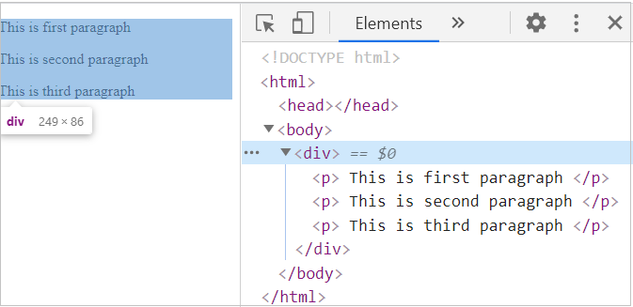

Span Element
Similar to the division element, the span element is also used to group various other HTML tags to apply some common styles.
It is defined by using <span> ...</span> tag.
The span element is by default inline in nature, and hence no new line is added after the span ends. This tag is preferred only when we cannot use any other semantic tags.
Copy the below code into your Visual Studio Code workspace.
demo.html
- ​<!DOCTYPE html>
- <html>
- <body>
- <div>
- <span>first section of paragraph</span>
- <span>second section of paragraph</span>
- </div>
- </body>
- </html>
To execute this code:
- Right-click on the file demo.html
- Select the option "Open with Live Server"
- Right-click on the browser, and select the inspect option.
In the pop-up window, observe the 'Elements' tab as below:
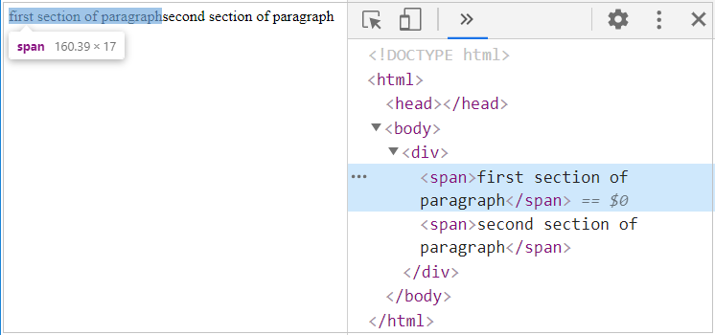
We can observe that no newline is added after the span ends since the span element is an inline-level element by default.
List - Need

We commonly come across requirements in our web applications where we need to group and display related items in an easily readable manner to the end-user.
Consider, for example, while developing a tourism website. Terms and Conditions would be definitely one of the web pages which we might need to design for this website.
The terms could possibly be displayed as shown:
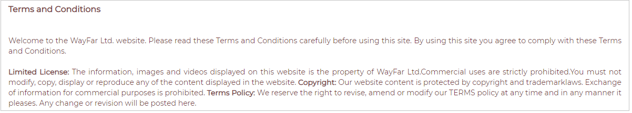
Here, the points are mentioned as continuous sentences in a paragraph. This way of presenting the terms and conditions would lead to difficulty for the reader to make out each point in a uniquely distinguishable and identifiable manner.
Let us learn how to redesign this page to improve readability, make the page as presentable to end-user as shown below:
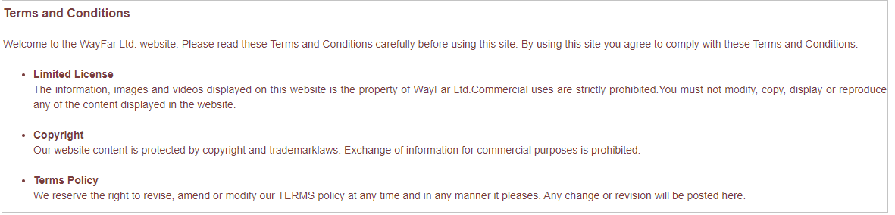
Consider another scenario where we need to display different awards which have been won by the tourism company as shown below.
Here also, we surely can get to know the awards received. However, it is difficult to comprehend how many awards were won. Displaying the same data in a numbered list as shown below can help make the same content readable, and easy to comprehend details.
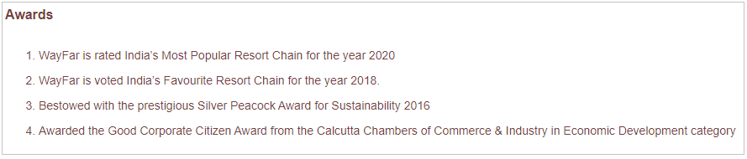
This is why we need lists on a web page.
With HTML Lists, we can group related items and display the items one after the other. This makes it easy to locate a particular item on the web page. In short, HTML Lists help in adding structure and order to related items on a web page, thereby ensuring better readability of related content.
Let us see different types of lists
HTML lists come in three basic flavors and each one has a specific implementation.
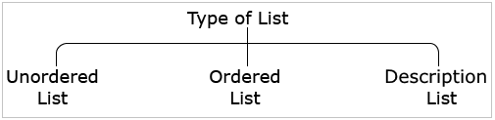
Unordered List - Syntax

HTML lists come in 3 basic flavors:
- Unordered list
- Ordered list
- Description list
Each one has a specific purpose and meaning.
Let us start with the unordered list.
An unordered list is used to create a list of related items, in no specific order, like in the Terms and Conditions page where there is more focus on ensuring the readability of content by listing out points but not much concern about the specific order of points.
- An unordered list starts with the <ul> tag.
- Each item within the list technically referred to as 'list-item' enclosed within the <li> tag.
For example, to generate an unordered list as seen below :
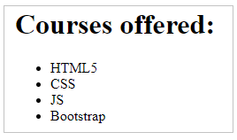
The following snippet can be used.
- <h1>Courses offered:</h1>
- <ul>
- <li>HTML5</li>
- <li>CSS</li>
- <li>JS</li>
- <li>Bootstrap</li>
- </ul>
Let us learn how to customize the unordered list appearance.
Unordered List - Bullet Types

The types of bullet points can be customized in an unordered list by using the list-style-type property provided by CSS.
For example, if we want our list to be displayed as below:
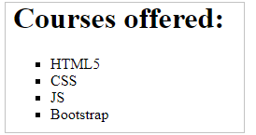
The corresponding code to achieve this requirement is:
- <h1>Courses offered:</h1>
- <ul style="list-style-type: square;">
- <li>HTML5</li>
- <li>CSS</li>
- <li>JS</li>
- <li>Bootstrap</li>
- </ul>
The possible values for the list-style-type property are :
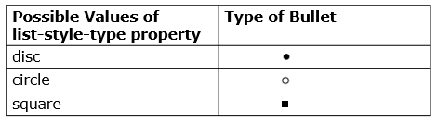
By default, the value 'disc' will be assigned to the property.
Let us learn how to nest the unordered list while designing a web page.

Note: There is a type attribute to define the types of bullet points, which is not recommended to be used as per the latest HTML version.
Unordered List - Nesting
In HTML, it is also possible to nest lists into different levels.
For example, if you want to create a nested list as shown below:
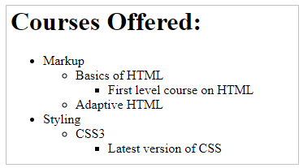
Corresponding HTML code to achieve this requirement is:
- <h1>Courses Offered:</h1>
- <ul>
- <li>Markup
- <ul>
- <li> Basics of HTML
- <ul>
- <li> First level course on HTML </li>
- </ul>
- </li>
- <li> Adaptive HTML </li>
- </ul>
- </li>
- <li>Styling
- <ul>
- <li> CSS3
- <ul>
- <li> Latest version of CSS </li>
- </ul>
- </li>
- </ul>
- </li>
- </ul>

If you observe the above-given code snippet, based on the enclosure of the inner <ul>... </ul> elements on various lines, the default bullet styling of unordered list element has been populated on to the web page.

Ordered List - Syntax

An ordered list is used when the order of items is important and we want to create a list of related items, in a specific order.
- An ordered list starts with the <ol> tag.
- Each item within the list technically referred to as 'list-item' enclosed within the <li> tag.
For example, to generate an unordered list as seen below :
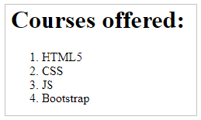
The below-given code snippet can be used to achieve this requirement.
- <h1>Courses offered:</h1>
- <ol>
- <li>HTML5</li>
- <li>CSS</li>
- <li>JS</li>
- <li>Bootstrap</li>
- </ol>
Let us learn how to customize the ordered list appearance.

Best Practice:
It is a good practice to avoid more than one list item per line.

Ordered List - Bullet Types
The types of bullet points can be customized in an ordered list by using the list-style-type property provided by CSS.
For example, if we want our list to be displayed as below:
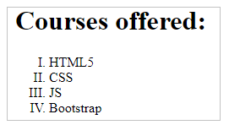
The corresponding code to achieve this requirement is:
- <h1>Courses offered:</h1>
- <ol style="list-style-type: upper-roman;">
- <li>HTML5</li>
- <li>CSS</li>
- <li>JS</li>
- <li>Bootstrap</li>
- </ol>
Some of the following values for the list-style-type property are:
Some of the possible values of the list-style-type property | Type of bullet
1,2,3,4 ... | decimal
I, II,III,IV,.. | upper-roman
I,ii,iii,iv,.. | lower-roman
A,B,C,D,.. | upper-latin
a,b,c,d,.. | lower-latin
By default, the 'decimal' value will be set to the CSS property. We can also have 'none' value for the list-style-type property if we do not need any bullets to be present in the list.
Let us have a glance over some of the attributes which help us to customize the ordered list while designing a web page.
Ordered List - Attributes

Some of the attributes which can be used with this element are:
Name | Description
start | Specifies the initial value of the list.
reversed | Specifies the pattern to be rendered in reversed order.
type | Specifies the different numbering values like :  - 1 for number (default).  - a for lowercase alphabets.  - A for uppercase alphabets.  - i for lowercase roman numeral value.  - I for uppercase roman numeral value.

For example:
Consider the following code snippet:
- <h1>Courses offered:</h1>
- <ol type="a" start="d" reversed>
- <li>HTML5</li>
- <li>CSS</li>
- <li>JS</li>
- <li>Bootstrap</li>
- </ol>
The above code will generate lists of course offered on the web page as shown below:
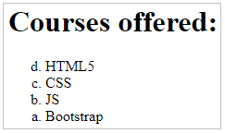
Let us learn how to nest the ordered list while designing a web page.

Best Practice:
It is recommended to use list-style-type CSS property instead of the <ol> ... </ol> type attribute unless the pattern of numbering ordering of the list is considered to be very important.
Ordered List - Nesting

In HTML, it is also possible to nest lists into different levels.
Ordered lists can be nested with ordered lists or unordered lists.
For example, if you want to create a nested list as shown below:
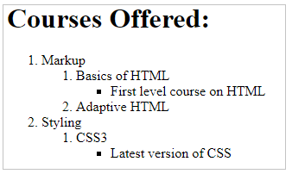
The corresponding code to achieve this requirement is:
- <h1>Courses Offered:</h1>
- <ol>
- <li>Markup
- <ol>
- <li> Basics of HTML
- <ul>
- <li> First level course on HTML </li>
- </ul>
- </li>
- <li> Adaptive HTML </li>
- </ol>
- </li>
- <li>Styling
- <ol>
- <li> CSS3
- <ul>
- <li> Latest version of CSS </li>
- </ul>
- </li>
- </ol>
- </li>
- </ol>

If you observe the above-given code snippet, based on the enclosure of the inner <ol> ... </ol> and <ul>... </ul> elements on various lines, the customized list has been populated on to the web page.
Description List

Now, let us move to the Description lists.
Description lists are used to contain name-value groups, where names can be a list of terms and values can be their related descriptions.
The description list otherwise called definition list arranges items in the same way as the meaning associated with each word is arranged in a dictionary as below:
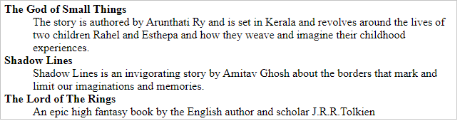
- Description lists are created with the <dl> tag.
- The term is placed within <dt>.. </dt> tag and description is placed between <dd>...</dd> tag.
Let us see the syntax now:
- <dl>
- <dt> Description Term 1 </dt>
- <dd> Description Definiton 1 </dd>
- <dt> Description Term 2 </dt>
- <dd> Description Definition 2 </dd>
- </dl>

Best Practice:
It is recommended not to use the <dl> tag while designing any dialogues concepts.
Quotation Element - Syntax

Quotation element is defined using <blockquote>...</blockquote> tag.
The source of the quote is mentioned in the cite attribute of the blockquote element.
- <!DOCTYPE html>
- <html>
- <body>
- Below line has been referred from OWASP website:
- <blockquote cite="https://owasp.org/">
- The Open Web Application Security Project® (OWASP) is a nonprofit foundation that works to improve the security of software.
- </blockquote>
- </body>
- </html>

The content enclosed inside <blockquote>...</blockquote> will appear in Chrome browser with default indentation as observed below.
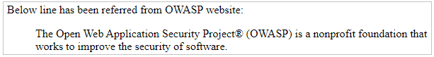

Link Element - Need

A website necessarily is a collection of related web pages, where each web page is typically created for a particular purpose.
When developing any website:
- Each web page is necessarily coded in individual HTML files.
- To see a particular web page, the respective HTML file has to be opened up in a browser.
Below are some concerns pertaining to accessing the website developed:
- For a developer who has access to the source code of the individual HTML files, he or she can open the respective HTML on his browser. But if you are not a developer, you do not have access to the source code. Then how can you view the individual web pages?
- If you are trying to access the website over a network as a regular user, then also you will not be able to view the individual web pages unless you know the exact HTML file name and path.
- Moreover, trying to access individual web pages explicitly does not give a feeling that these web pages necessarily belong to one website or domain.
This is why the concept of hyperlinking documents or web pages have been introduced.
Below are the advantages if hyperlinks are used:
- We can create connections or links between HTML documents/web pages and users can navigate from one web page to another by clicking on "hyperlinks".
- We would now feel that we have a website which is a collection of interconnected web pages.

Link Element - Syntax
Link elements are defined using <a> .. </a> tag as below:
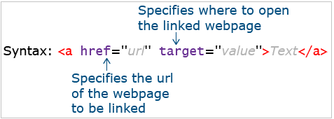
Text / Image can be used as link.
Text / Image that provides such a link is called "hyperlink".
Link ELement - Types

A hyperlink is a prime way in which users can navigate from one web page to another. A hyperlink can point to another web page, or website, or files, or even specific locations on the same web page.
Hyperlinks can be of any of the below types:
Text hyperlink:
- A clickable text is used to take the user to another web page. Largely, we use text-based hyperlinks.
- This text usually appears with an underline and in a different color.
- This color mapping is automatically done by the browser for all text hyperlinks.
Image hyperlink:
- A clickable image is used to take the user to another web page.
Bookmark hyperlink:
- A clickable text/image is used to take the user to another part of the same web page.
Email hyperlink:
- It allows users to send an email by clicking on that link.
Contact number hyperlink:
- It allows the user to call a number by clicking on that link.

Creating Link Elements

Text hyperlink:
The text is mentioned within the start tag <a> and end tag </a> and is displayed on the screen in a clickable manner
- <a href="Enquire.html"> Click here to connect to us </a><br/>
- <a href="http://www.google.com"> Click here to go to Google website </a>
Image hyperlink:
We can also have an image-based hyperlink. For this, we need to wrap the image inside an anchor tag.
- <a href="http://www.google.com">
- <img src="google.jpg" />
- </a>
On click of the image, the user gets redirected and the google.com website gets loaded in the browser tab.
Creating Link Elements

Bookmark hyperlink:
When a web page is lengthy, we commonly come across icons or links that say "Go to Top" or "Go to Bottom". Click on these links does take the user to the top of the page or bottom, as applicable. Sometimes we also observe, on click of a text in the menu bar, the page auto scrolls to that particular section on that page. This is achieved by using the Bookmarking concept and the same is implemented by using hyperlinks.
- <h2 id="top">Topic</h2>
- <p>Detail……</p>
- <p>Detail……</p>
- <p>Detail……</p>
- <a href="#top">Go to Top</a>
Email hyperlink:
To send an email on click of a hyperlink, use the below syntax:
- <a href="mailto:someone@xyz.com?Subject=Hello%20again">Send Mail</a>
On click of the link, the installed mail client on the computer gets activated for sending the email. An installed email client should necessarily be installed on the computer for this to work.
Contact number hyperlink:
To make a call to a number on click of a hyperlink, use the below syntax:
- <a href="tel:+9999">Call Us</a>

Link Element - Target Attribute
Link element has an attribute named 'target' which specifies in which window, the hyperlinked content should appear.
The target attribute can hold the following values:
The possible value of "target" | Description
_blank | Opens a web page in a new window or tab
_self | Opens a web page in the same window (default)
_parent | Opens a web page in the parent frame
_top | Opens a web page in the full body of the window
frame-name | Opens a web page in a named frame
For example:
- <a href="https://owasp.org/" target="_blank">Link to OWASP web site</a>
In the above example, the https://owasp.org/ website opens in a new window.
Link Element - Best Practices

Best Practices:
- It is a best practice to use href and rel attributes for links based on the requirement.
- It is recommended to use the values like noopener and noreferrer for the rel attribute in links to avoid security threats such as reverse tabnabbing.
For example:
- <a href="http://example.com" target="_blank" rel="noopener noreferrer">
- Example site
- </a>
In the above example:
- rel=”noopener” attribute prevents the new page to be accessed by the window.opener property by ensuring it executes in a separate process.
- rel=”noreferrer” attribute is similar to noopener along with it prevents passing on the referrer details to the new page.

Tryout 1 - Link Element

Problem Statement:
Make below observation(s) in the given code-snippet:
- Defining hyperlinks using the Link element.
- The first link opens in a new tab.
- The second link opens in the same tab.
Activities:
Change the value set for the href attribute and observe the output.
Note: You can execute this tryout in your Visual Studio code IDE or any other editors.
- <html>
- <body>
- <a href="https://owasp.org/" target="_blank">
- Opens OWASP website in new tab
- </a>
- <br/>
- <a href="https://owasp.org/" target="_top">
- Opens OWASP website in same tab
- </a>
- </body>
- </html>

Link Element as a Bookmark - Tryout

Problem Statement:
Copy the given code to your Visual Studio Code workspace.
Scroll down till the bottom and click on the link "Go to top" and observe the output, vice-versa check for "Go to Bottom" functionality also.
Activity:
Change the #id and observe the output.
Note: You can execute this tryout in your Visual Studio Code IDE or any other editors.
demo.html
- <!DOCTYPE html>
- <html>
- <body>
- <p id="top">
- Top of the page
- </p>
- <a href="#bottom">
- Go to bottom
- </a>
- <p>
- A hyperlink is a prime way in which users can navigate from one web page to another. A hyperlink can point to another web page, or website, or files, or even specific locations on the same web page.</br>
- </p>
- <p>
- Hyperlinks can be of any of the below types:
- </p>
- <p>
- <p>
- <b> Text hyperlink:</b>
- </p>
- <p>
- A clickable text is used to take the user to another web page.</br>
- Largely, we use text-based hyperlinks.</br>
- This text usually appears with an underline and in a different color.</br>
- This color mapping is automatically done by the browser for all text hyperlinks.</br>
- </p>
- <p>
- <b> Image hyperlink:</b></br>
- </p>
- <p>
- A clickable image is used to take the user to another web page.</br>
- </p>
- <p>
- <b> Bookmark hyperlink:</b></br>
- A clickable text/image is used to take the user to another part of the same web page</br>
- </p>
- <p>
- <b> Email hyperlink:</b></br>
- It allows users to send an email by clicking on that link.</br>
- </p>
- <p>
- <b> Contact number hyperlink:</b></br>
- It allows the user to call a number by clicking on that link.</br>
- </p>
- <p> Let us learn about Bookmark hyperlink through this demo. </p>
- <p>
- <b>Bookmark hyperlink:</b></br>
- When a web page is lengthy, we commonly come across icons or links that say "Go to Top" or "Go to Bottom". </br>
- Click on these links does take the user to the top of the page or bottom, as applicable.</br>
- Sometimes we also observe, on click of a text in the menu bar, the page auto scrolls to that particular section on that page. </br>
- This is achieved by using the Bookmarking concept and the same is implemented by using hyperlinks.
- </p>
- <p id="bottom">
- Bottom of the page
- </p>
- <a href="#top">
- Go to top
- </a>
- </body>
- </html>

Link Element - Tryout 3

Problem Statement:
Copy the given code to your Visual Studio Code workspace.
Activity:
Change the email ID and phone number and observe the output.
Note: You can execute this tryout in your Visual Studio Code IDE or any other editors.
demo.html
- <!DOCTYPE html>
- <html>
- <body>
- Any suggestions or feedbacks regarding our services?
- <a href="mailto:abcd@xyz.com?Subject=Hello%20again">Send Mail</a> <br>
- <a href="tel:+919445200125">Call Us</a> <br>
- </body>
- </html>
Link Element – Exercise
Problem Statement:
Consider the below Home Page of Hussain's Shopping Application.
Enhance semantics of content by adding the Link elements in the below-given code Homepage.html.
Links to be added:
- Link "Login", "SignUp" and "Track order" to "Login.html", "SignUp.html" and "Track.html" page respectively.
- Bookmark each category to its details.
Homepage.html
- <!DOCTYPE html>
- <html>

- <head>
- <meta name="keywords" content="Online, Shopping" />
- <title>Hussain's Shopping</title>
- </head>

- <body>
- <header>
- <nav> Login | SignUp | Track order </nav>
- <h1>Welcome to Hussain's Shopping</h1>
- <nav> Clothing | Electronics </nav>
- </header>
- <article>
- Hussain's one-stop solution for all your shopping needs ! Dont believe us? Click on the offers and
- check it out for yourself !! <h2 id="Clothing"> Clothing </h2>
- <h2 id="Electronics"> Electronics</h2>
- </article>
- <footer>
- <nav> About Us | Privacy Policy | Contact Us | FAQ | Terms & Conditions </nav> Copyright 2016 | ETA UI and MarkUp
- </footer>
- <aside> Like and Connect with us FB Twitter g+ </aside>
- </body>

- </html>

Expected Output:
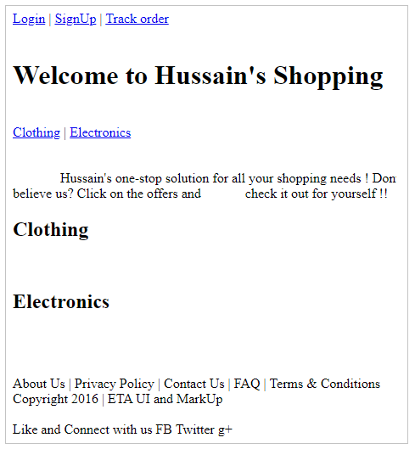

Text - level Semantic Elements - Need

When displaying any content, specifically some kind of text/numerals on web pages, we might need to format certain portions of the content.
Consider the below screenshot:
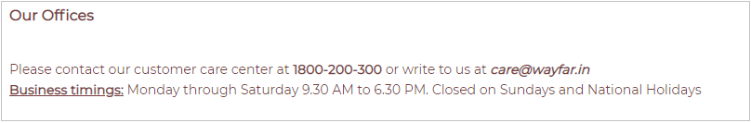
- The phone number is the quickest connection as it invites instant response and hence the number is in bold.
- The email should be clearly readable and distinguishable and hence shown in italics.
- Business Timings details need to be considered as very important and it should be noted by the user to know when the company team would be available to reachable to solve their queries. This field can be underlined.
Adding a bit of formatting to the text can help in adding appropriate emphasis and makes it easier for the user to figure the important information on the screen very quickly.
Widely Used Text-Level Semantic Elements

The table below lists widely used text-level semantic elements supported in HTML5.
Element | Description
abbr | Defines abbreviation or acronym
q | Represents text quoted from another source by adding quotation mark (" ")
small | Displays text in relatively smaller font-size
mark | Highlights text
strong | Displays text in bold
em | Displays text in the italic or emphasized format
sub | Displays text as subscript
sup | Displays text as superscript
span | Provides styling to text
br | Breaks line of text

Widely Used Text-Level Semantic Elements

Below are some text semantic tags and their usage:
The <strong> element:
- Make the text appear bolder
- <strong>Text in bold</strong>
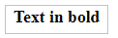
The <mark> element:
- Highlighted text like the way we do in a paper using a highlighter
- HTML <mark>Marked</mark> Formatting
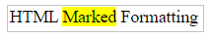
The <sup> element:
- Display text like superscript
- Example of <sup>superscripted</sup> text.
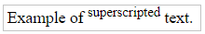
The <sub> element:
- Display text like subscript
- Example of <sub>subscripted</sub> text.
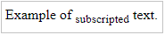
The <em> element:
- Emphasize text
- <em>Text emphasized</em>

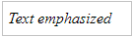

The <small> element:
- Display text in relatively smaller font
- <h2>Text <small>Small</small> in HTML</h2>
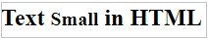
The <del> element:
- Strikethrough text
- This is <del>deleted</del> content.
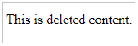
Note: The <sup> and <sub> elements can be replaced by the CSS property "vertical-align" especially while designing a logo of a product or a business that uses a raised baseline.

Text-Level Semantic Elements - Best Practices

Best Practices:
- Do not use the <em> element to display any warning /caution content in any web page creation.
- Avoid using <em> just to apply italic styling instead it is recommended to use CSS font-style property for italic styling.
- Avoid <s>,<i>,<b> and <u> elements while coding any web page.
- It is a best practice to include Title Attribute for <abbr> element.
- Avoid the <span> element as much as possible.

Character Entities

Some characters are reserved in HTML.
For example: If you use the less than (<) or greater than (>) sign in your content, the browser may mix them with HTML tags.
Also, some characters are unavailable on the keyboard.
For example: ©
Character entities are used to include such character content on a web page.
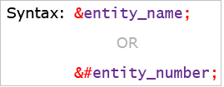
The table below lists widely used character entities supported in HTML5.
Character | Description | Entity Name | Entity Number
 | Non-breaking space | &nbsp; | &#160;
< | Less than | &lt; | &#60;
> | Greater than | &gt; | &#62;
& | Ampersand | &amp; | &#38;
© | Copyright | &copy; | &#169;
€ | Euro | &euro; | &#8364;
£ | Pound | &pound; | &#163;
® | Registered trademark | &reg; | &#174;

Need of HTML Table Element

Consider the screen below from a web application on tourism, which displays details about the best time to visit different places.
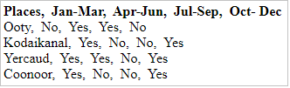
Assume that we need to now quickly find out which of the places are best to be visited in the Jul-Sep quarter.
It is quite difficult to comprehend this information from this display. We will need to go line by line and find out yes/no by looking at the order of data displayed in each line. If we miss the correct order of data in each line, there is a possibility of miscalculating the required information. If this data is displayed in a ‘tabular format’, we can quickly get the required data.
With a tabular format of data display, the information we need can be easily interpreted by making visual associations between row and column headers.
This is why we need HTML Tables. HTML Tables provide a means by which we can create a tabular format of data on the web.
Organizing Data as Tables - Examples

An HTML table is a great way to display data that make more sense in spreadsheet formats as shown below.
Tour package information and comparisons:
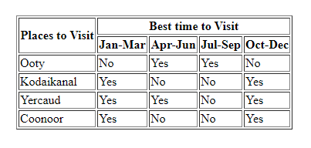
Displaying price comparisons:
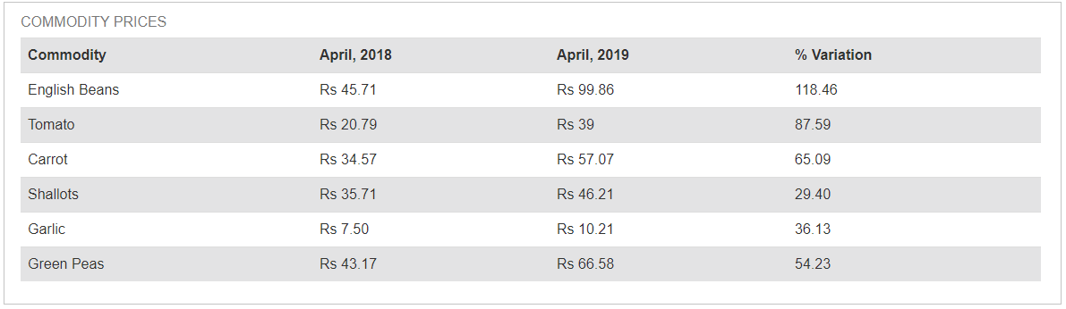
Nutritional facts:
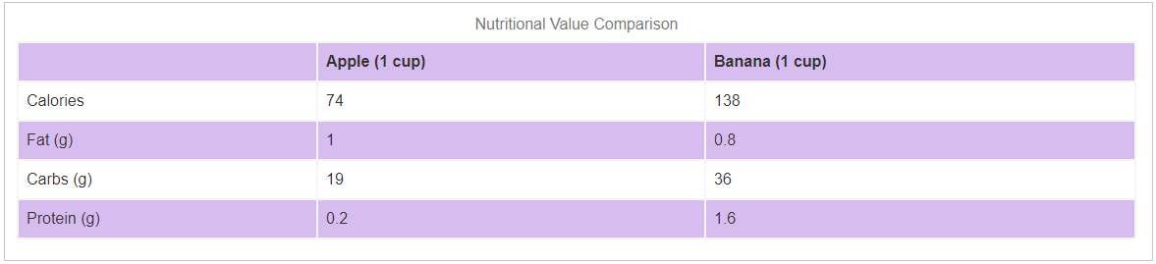
Table Element - Syntax

The table element is defined in HTML using <table>...</table> tag
It contains table header and table body.
The table header is for adding header information like column headers and the table body is for table contents.
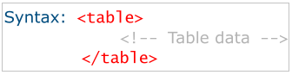
The following elements are used within the table element:
Element | Description
caption | Defines table heading
tr | Defines row of the table
th | Defines heading of the column
td | Defines data of column
thead | Defines header part of the table
tbody | Defines the content part of the table
colgroup | Helps to logically group two or more consecutive columns
Table Structure:
- <table>
- <caption>Table heading</caption>
- <thead>
- <tr>
- <th>Column 1 heading</th>
- <th>Column 2 Heading</th>
- </tr>
- </thead>
- <tbody>
- <tr>
- <td>Column 1 data</td>
- <td>Column 2 data</td>
- </tr>
- </tbody>
- </table>

The above code snippet displays the below table on the web page:
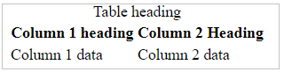
Consider the below code snippet:
- <html>
- <table>
- <thead>
- <th>Back-end JS </th>
- <th>Front-end JS </th>
- </thead>
- <tbody>
- <tr>
- <td>Node</td>
- <td>React</td>
- </tr>
- <tr>
- <td>Express</td>
- <td>Angular</td>
- </tr>
- </tbody>
- </table>
- </html>
The output for the above code snippet will be as shown below:
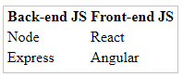
In the above-mentioned code we can observe that:
- The <table> element encloses all the other table elements in it.
- The optional <thead> and <tbody> elements helps us to logically divide the table content.
- The <th> element is used to define the column heading.
- The <tr> element creates a new row.
- The <td> element creates a new table column.

Suppose the developer has to design an HTML table as shown below:
Note that, Node and Express are logically related columns, and the same styling should be applied for both.
The <colgroup> element in HTML helps us to group the related columns especially to provide some common CSS property.
The HTML code snippet to achieve the above requirement is:
- <table>
- <caption>MERN stack developer program</caption>
- <colgroup>
- <col>
- <col style="background-color:lightblue;">
- <col span="2" style="background-color: lightgreen;">
- <col style="background-color: lightpink;">
- </colgroup>
- <tr>
- <th>Technology</th>
- <td >MongoDB</td>
- <td >Node</td>
- <td >Express</td>
- <td>React</td>
- </tr>
- <tr>
- <th >Description</th>
- <td>The database</td>
- <td>Node is the base for server side scripting</td>
- <td>JS framework for web server development</td>
- <td>JS library to design the front end</td>
- </tr>
- </table>

In the above-mentioned code we can observe that:
- The <table> element encloses all the other table elements in it.
- Line numbers 3-7 code which has been enclosed between the <colgroup> element helps us to logically group the related column data and also customize the default look and feel of the respective column through CSS properties.
- The <colgroup> element has an attribute "span" which carries the information regarding how many columns are to be grouped together. The default value of this span attribute is 1.
- The <tr> element helps to create a new table row.
- The <td> element helps to create a new table column.

Table Element - Best Practices
Best Practices:
- It is important that the table should be accessible to visually impaired users and hence it is recommended to provide a table description using the <caption> element.
- It is a best practice to associate table headers <th> elements with their <td> cells.
- A table can be styled using appropriate CSS properties like height, and width for customizing the default look and feel of this element.

Colspan and Rowspan Attributes

The elements <td > and <th> supports the attributes namely colspan and rowspan which helps to merge the table cells accordingly.
The colspan attribute accepts a numeric value and merges specified numeric value of columns together whereas, the rowspan attribute accepts a numeric value and merges specified numeric value of rows together.
Consider the below table with 4 rows and 4 columns.
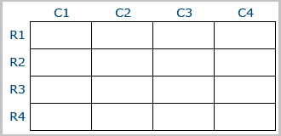
For example, if we provide colspan attribute with a value 2, then 2 columns of the table will be merged as shown below:
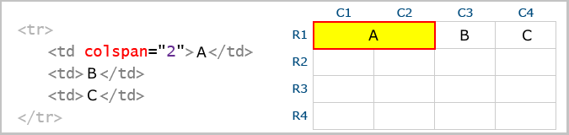
And, if we provide rowspan attribute with a value 2, then 2 rows of the table will be merged as shown below:
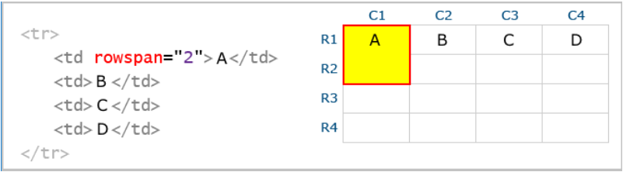
Table Elements - Exercise
Problem Statement:
Consider the Details page of Hussain's Shopping application. Enhance its functionality by adding a table element to display the available mobile inventories to populate the below-given output.
Details.html
- <!DOCTYPE html>
- <html>
- <head>
- <meta name="keywords" content="Online, Shopping" />
- <title>Hussain's Shopping</title>
- </head>

- <body>

- <table border="1">
- <caption>Mobile Inventories Available at Hussain's Shopping!</caption>
- <!-- Design the table here -->
- </table>
- </body>
- </html>
Expected output:
